**Use Cases**

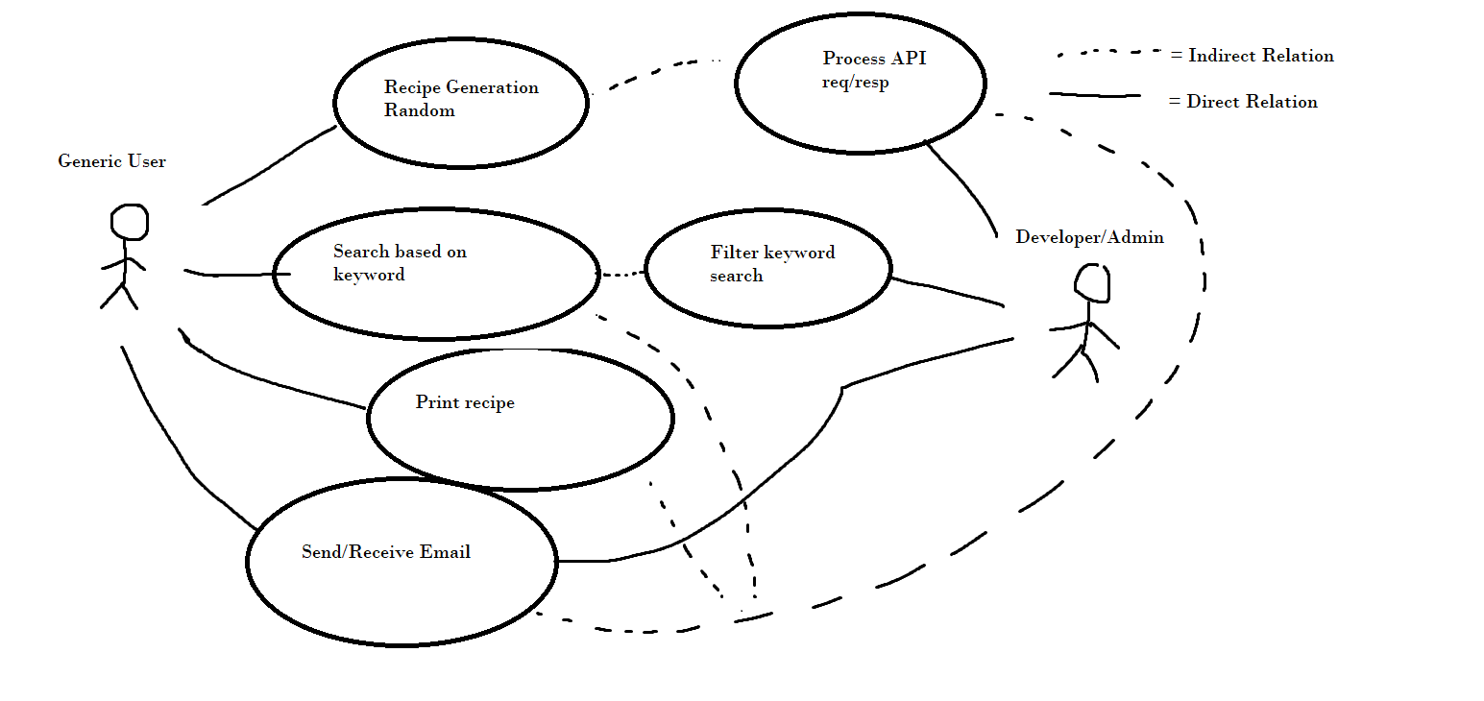

* Use Case 1- User searches for Recipe
  + Description- User accesses a website to search for a recipe.
  + Actors- Generic User
  + Organizational Benefits- traffic to the website which can result in ad revenue, etc.
  + FOU- Not evaluated, but most customers who use site may search for items
  + Triggers- Searching in designated box
  + Preconditions- User is on main page
  + Postconditions- Result is returned
  + Main Course
    - Website prompts search box
    - User searches
    - Result is returned
  + Exceptions
    - User may randomly generate, or click on category of foods rather than search
* Use Case 2- Random Recipe Generation
  + Description - User clicks random recipe button and random recipe is presented
  + Actors- Generic User
  + Organizational Benefits- traffic to the website which can result in ad revenue, etc.
  + FOU- Not evaluated, but most customers who use site may randomly generate items
  + Triggers- Clicking random search buttons
  + Preconditions- User is on main page
  + Postconditions- Result is returned
  + Main Course
    - Website prompts with button
    - User clicks
    - Result is returned
  + Exceptions
    - Users may search or click category, versus clicking random.
* Use Case 3- Category Click
  + Description- User clicks a category
  + Actors- Generic User
  + Organizational Benefits- traffic to the website which can result in ad revenue, etc.
  + FOU- Not evaluated, but most customers who use site may click categories
  + Triggers- Clicking category
  + Preconditions- User is on main page
  + Postconditions- Result is returned
  + Main Course
    - Website prompts with options
    - User clicks
    - Result is returned
  + Exceptions
    - User may search of randomly generate and not click a category